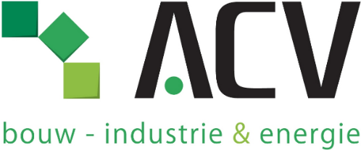

October 8, 2024

**Dear colleagues, exempts and non-exempts,**

On September 27, the employer informed us about the intention to reorganize, which may impact 125 to 148 colleagues. Almost all affected employees have now been informed about the potential impact of this reorganization on their jobs.

As the largest employee representation within J&J Belgium, we will advocate for the maximum preservation of jobs. We want to provide necessary support to the affected colleagues, non-exempts and exempts. We aim to answer their questions, assist in individual discussions, and review the employer's proposals. We can also provide necessary explanations regarding the social plan, that ACV negotiated as part of the employee representation.

Our impact in discussions with the employer is directly proportional to our number of members. Therefore, we warmly invite you to join the largest union at J&J Belgium, so we can better defend your rights as non-exempts or exempts.

ACV members receive an annual union bonus of €145 and regular updates via newsletters. Additionally, you have access to many membership benefits through Ekivita.

Membership in ACV is anonymous, our employer does not know who is member.

You can become a member via the QR code below or contact us personally.

Kind regards,

Your ACV-team

[www.medicijntje.be](http://www.medicijntje.be)